Qualification handbook

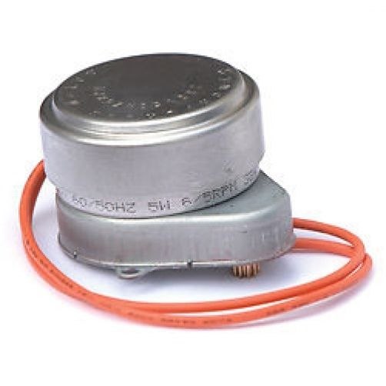

Introduction
Cert-ain Certification Ltd. is a certification body accredited by the regulatory authorities to offer a range of qualifications for operatives working in the building services engineering sector.
The Cert-ain Certification Ltd. qualifications are designed to be user-friendly for both the assessment centres delivering them and the candidates undertaking them. Our aim is to keep things as simple as possible whilst at the same time, maintaining the highest possible industry standards.
Our qualifications are designed to encourage learning and achievement, providing operatives with the appropriate knowledge and skills to help them progress in their chosen career.
Central heating systems and controls
The aim of this handbook is to provide the necessary information for those wishing to undertake the central heating systems and controls qualification.
The handbook also aims to provide assessment centres with details of the requirements for delivering the qualification
Contents
Introduction | 2
Central heating systems and controls qualification | 2
Summary | 3
Eligibility | 3
Training | 3
Reference material | 3
Assessment criteria | 4
Assessment process | 5
Assessors | 5
Internal verifiers | 6
Centre approval | 6
External verifiers | 6
Contact details | 6

Central heating systems and controls

Summary

Individuals holding the qualification shall be recognised as being competent against the assessment criteria listed on page 4.

All succesful individuals will be issued with a Cert-ain Certification Ltd. certificate of competence.

Eligibility

Individuals wishing to take the Central Heating Systems and Controls qualification should possess one of the following qualifications:

- Cert-ain Certification Gas Diploma (Gas Safety)*
- Domestic ACS CCN1* and CENWAT*
- OFTEC 10-101*
- N/SVQ Level 2 or 3 in plumbing*
- N/SVQ Level 2 or 3 in heating and ventilating*
- N/SVQ Level 2 or 3 in gas installation/maintenance*
- N/SVQ Level 2 or 3 in oil-fired technical services*

*or equivalent

Individuals with any disabilities that may affect their ability to successfully complete the qualifications should inform the assessment centre on application. Assessment centres shall consider any reasonable requests for any aids or equipment that are designed to alleviate any disability providing that the required assessment standard is not compromised.

Training

Assessment centres deliver a training programme focussing on the contents of a number of key ‘normative’ documents, some of which are freely downloadable from the internet. The training programme is designed to help operatives to prepare for the assessment process.

Reference material

The reference material used for the training and assessment:

- Building Regulations Approved Documents G, L and P
- HSE GS38 Electrical test equipment for use on low voltage systems
- Electricity Safety Council Best Practice Guide No 2. (Safe isolation)
- BS 6798 Specification for selection, installation, inspection, commissioning, servicing and maintenance of gas-fired boilers of rated input not exceeding 70 kW net
- CIBSE Heating Design Guide
- Manufacturers instruction’s

Assessment criteria
Performance

 | In relation to central heating controls, you will be able to:
1 | Measure and interpret resistance readings to ensure that it is safe to establish/re-establish the electrical supply
2 | Measure and interpret voltage readings to ensure safe electrical operation
3 | Wire a complete central heating system including the following components: motorised valves; room thermostats; time and temperature controls; pump over-run requirements (where appropriate)

Knowledge and Understanding

 | In relation to central heating system design, you will need to know and understand:
1 | The component parts of an open vented system
2 | Awareness of one pipe systems
3 | The component parts of a sealed system
4 | System plans including 2-port and 3-port valves
5 | Pump overrun requirements including safety precautions
6 | Energy efficiency requirements relating to boiler installations.
7 | Boiler plus requirements
8 | Building regulation requirements (Part L or their equivalents in the devolved administrations) affecting boiler installations
9 | Cylinder types e.g. direct, indirect, twin coil – possibly connected to solar thermal
10 | Unvented hot water systems: Component parts: maintenance tasks (not requiring certification).
11 | System water cleansing, flushing and treatment including draining and refilling systems
12 | Design, heat loss and comfort conditions including: comfort conditions (occupancy, desired usage patterns, room temperatures); calculation of heat losses; heat transfer/ emitters; sizing the system (including system pipework, any intermittent heating allowance, pump duty); thermostatic radiator valves; system bypass; low temperature systems; low carbon heating systems – interactions with gas boilers.
13 | Commissioning the system including: hydronic balancing; Benchmark.
14 | Fault diagnosis relating to manufacturers flowchart.

Assessment process

Operatives will be required to successfully complete a theory examination and a practical assessment that will take between 2-3 hours to complete. The pass-rate is 100%, operatives are allowed up to 3 attempts.

Theory

- The pass rate for the theory examination is 100%
- If the candidate does not achieve 100% on the first attempt, they will be allowed a second attempt on at the questions that they got wrong on the first attempt
- If the candidate does not achieve 100% on the second attempt, providing they have achieved over 80%, they will be orally questioned by the assessor to establish their competence
- Candidates not achieving 80% after the second attempt or 100% after oral questioning will be deemed to be unsuccessful
- Unsuccessful candidates will be required to retake the assessment in its entirety

Practical

- The pass rate for the performance assessment is 100%
- If the candidate does not achieve 100% on the first attempt, they will be allowed a second attempt at the tasks that they failed to complete successfully
- If the candidate does not achieve 100% on the second attempt, at the assessors’ discretion, they will be orally questioned by the assessor to establish their competence
- Candidates not achieving 100% after oral questioning will be deemed to be unsuccessful
- Unsuccessful candidates will be required to retake the assessment in its entirety

Assessors

Assessors shall be approved by Cert-ain Certification Ltd. They must be occupationally competent and hold a current relevant electrical qualification.

Assessors must also hold one of the following assessor qualifications:
- D32 or A1
- Level 3 certificate ‘assessing vocationally related achievement’ or suitable equivalent

Internal verifiers

Internal verifiers shall be approved by Cert-ain Certification Ltd. They must be occupationally competent and hold or be working towards one of the following internal verifier qualifications:

- D34 or V1
- Level 4 award ‘internal quality assurance of assessment processes and practice’ or suitable equivalent

Centre approval

All centres delivering the qualifications are subject to approval and monitoring to ensure that they have the appropriate personnel and facilities in place to deliver a fair and impartial training and assessment process.

The Cert-ain Certification Ltd. external verifier shall carry out quality assurance of the training, assessment and internal verification process. This includes sampling of:

- training and assessment facilities
- candidate records
- assessment decisions

External Verifiers

External verifiers shall hold or be working towards one of the following qualifications:

- D35 or V2
- Level 4 certificate ‘external quality assurance of assessment processes and practices’ or suitable equivalent

Contact details

If you would like any further information relating to the Cert-ain Certification Ltd. qualifications, please contact:

Cert-ain Certification Ltd.  58a High Street  Melbourne  Derbyshire  DE73 8GJ | Tel: 01332 987220  Fax: 01332 895989  Email: info@cert-ain.com  Web: www.cert-ain.com

